|  |  |  |  |  |  |  |  |  |  |  |
| --- | --- | --- | --- | --- | --- | --- | --- | --- | --- | --- |
| Risk assessments should be reviewed periodically, or after incidents and when significant changes in personnel or work practices occur. | | | | | | | | | | |
|  | **Location** | | | | |  | **Activity** | | |  |
|  |  | | | | |  |  | | |  |
|  | **Issue** | | | | |  |  | | |  |
|  |  | | | | | | | | |  |
|  |  | | | | | | | | |  |
|  | **Number** | **Hazard**  Something with the potential to harm: hazards listed should be all those present before controls are in place. | **Possible effects/harm**  Where a group of people may be affected differently, for example young people or expectant mothers, identify the separate effects/harm and risk rating. | **Risk rating H, M, L**  Indicate the rating prior to controls being in place. (See page 7 for guidance on rating the risk.) | **Detail existing controls**  Provide details of control measures already in place. If measures are detailed in other documents, state where. | | | **Detail further action required to reduce risk**  Note the action required, responsible person and target date. | **Revised risk rating  H, M, L**  Indicate the rating following implementation of controls. |  |
|  | 1 | e.g. Working plant (fixed or mobile) | e.g. Physical harm from moving machinery | e.g. H | e.g. Any rules put in place by the site operator for visitors. Warning signs etc. | | | e.g. Visiting officers to ensure that they are accompanied at all times while on site and that they adhere to any rules that the site operator has in place. | e.g. M |  |
|  |  |  |  |  |  | | |  |  |  |
|  |  |  |  |  |  | | |  |  |  |

|  |  |  |  |  |  |
| --- | --- | --- | --- | --- | --- |
|  |  | | | |  |
|  | **Declaration** | | | |  |
|  | Managers should monitor and review the application of the specified controls. | | | |  |
|  | **Prepared by** |  | **Date** |  |  |
|  |  |  |  |  |  |
|  |  |  |  |  |  |
|  | **Signature** |  | **Date** |  |  |
|  |  |  |  |  |  |
|  | I certify that all controls are in place which reduce risk to as low as is reasonably practicable, all staff have been informed and safe systems of work have been applied. | | | |  |

**Risk Rating**

|  |  |  |  |  |  |
| --- | --- | --- | --- | --- | --- |
| **Category** | **Insignificant** | **Minor** | **Moderate** | **Major** | **Catastrophic** |
| **Legal Compliance** | Internal Notifications | Reportable – No follow up | Reportable with Immediate actions | Reportable with follow up audit | Fines & Stoppage notices |
| **Safety and Health** | Near miss | First Aid treatment | Hospitalisation required - temporary condition | Permanent condition | Fatal |
| **Financial** | < $10k | $10k - $100k | $100k - $200k | $200k plus | >Insolvency |
| **Quality Assurance** | Internal review only | Recommendations | Improvement Notices | Non Comformaties | Stop Notice ` |
| **Reputation** | Internal stakeholders perception | One off media attention - local | Negative media coverage over 2 weeks | Business subject to ongoing public or Government criticism | Complete Loss of Business |
| **Business Continuity** | Incident can be delt with at site level within busienss hours | Incident can be delt with within 24 hours | Complete site disruption lasting more than 24 hours but less than 48 hours | Complete site disruption lasting more than 48 hours | Stoppage of all operations |
| **Environment** | No lasting environmental damage | Short term environmental damage to a small area | Medium term environmental damage to a widespread area | Widespread, long term environmental damage | Significant, permanent environmental damage |
| **Stakeholder complaints** | Internal review only - no action required | Internal review only - action required | Reported to Governing body or repeated internal reviews | Legal review required | Legal Convictions |

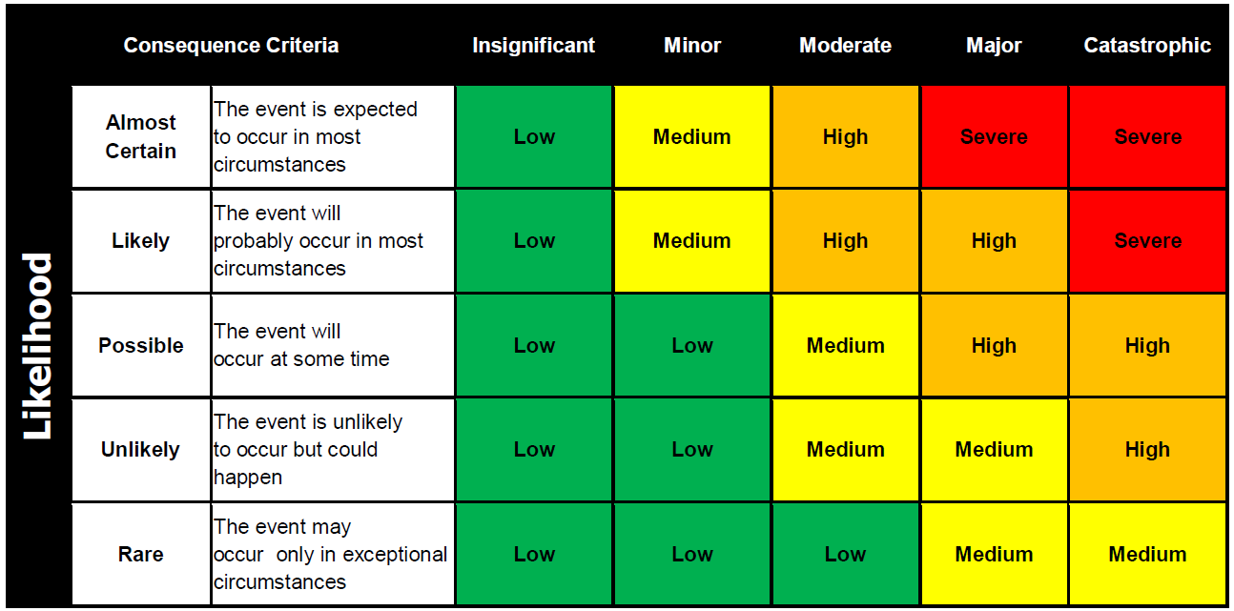

|  |
| --- |
| Significant Environmental Aspects (SEAs) are the ones that are rated as 'High" Risk. |
| An Enviornmental Aspects shall be considered SEA, where there is Legislative (L) or Community Concern (C ) overide |
| Manhari Metals shall take actions to address SEAs |

